Personal Training Client Intake Form
- Download this form, fill it in and send it back to me to apply for coaching. Please edit the file directly and save it before submitting on the application page of my website.
- You can use either the imperial or metric system to fill in this form. Just state which unit you used (e.g. cm, kg, lb, inch).

General
- Full legal name
- City
- Country
- Age
- Height
- Weight
- Body fat percentage (plus estimation method)
- Years of training experience

Goals

What is your primary fitness goal? Please outline in detail and be as specific as possible.

Why do you want to achieve this goal?

What limitations/obstacles are currently preventing you from achieving this?

Do you foresee any potential reasons for not reaching your goal?

Do you have a time frame on when you wish to achieve this goal?

Which of the following options best describes your dedication level? You can highlight or paste in the box below.
A: Sustainability is most important to me. As long as I’m moving in the right direction, I don’t care about the rate of progress.
B: I want to strike a reasonable balance between good results in proportion to effort and sustainability.
C: I will do whatever it takes to achieve maximum results without compromising my health.

Misc.

What is your occupation?
You may be general here, e.g. manager/business owner/doctor. The aim is to characterize your sleep cycle, stress and activity level.

Please list any pathologies or injuries you have had. This includes disabilities, allergies, illnesses, syndromes, disorders, etc.

Do you insist on any special diet? E.g. Ketogenic, Vegan, etc.

Are you currently taking any performance enhancing supplements? If so, please list them.

At this point, you may choose to return this form to me to obtain a price quote and complimentary consultation before filling in the rest.

Legal disclaimer: By returning this intake form, you declare that while Brodie Giesbrecht is your personal trainer, all the substances you use are obtained and used in accordance with their governing laws and you forego all rights to hold Brodie Giesbrecht liable for any damages caused in relation to following his advice as your coach.

Lifestyle Factors

Are there any times at which you are unable or unwilling to train? If so, please list them.

Which of the following options best describes your day to day activity level aside from your planned training sessions?
- Sedentary (e.g. office job)
- Somewhat active (e.g. you walk your dog several times a day or you commute by bicycle)
- Active (e.g. full-time PT, literally on your feet most of the day)
- Very active (e.g. involved in manual labor)

Which of the following options best describes your stress level?
- Stress-free (e.g. on holiday)
- Only occasional/mild stress (e.g. student not during exam period)
- Average stress (e.g. full-time work with deadlines and commuting)
- High stress (e.g. very high-paced work environment with great responsibility)

How is your sleep rhythm and quality?

How much caffeine do you consume daily on average or on a typical work day?

Training History

Have you previously followed a resistance training program?

How many times per week are you willing to work out?

What are the lightest barbell weight plates you have access to?

What are the smallest weight increments between the sets of dumbbells you have access to?

Does your available equipment differ from that in most commercial gyms? If so, please list the equipment you have access to. E.g. Do you train at a private gym or at home?

Strength level
State your current maximum abilities in weight times reps, e.g. 250 lb x 6
- Bench press
- Squat (excl. body weight)
- Chin-up (excl. body weight)
- Overhead press

Genetics
- Wrist circumference (smallest point)
- Ankle circumference (smallest point)
- How much did you weigh before you started lifting and what was your height at that point?
- Were you heavy as a baby?

Please attach a picture to this form in which the back of your right hand is clearly visible: place your right hand on a flat surface with your fingers touching each other and then take a picture of it.

Supplements
Please list all supplements you’re currently taking.

Current Program
Please describe or attach your current diet plan in detail.

Please describe or attach your current workout plan in detail.

Please submit this completed form to me via the application page on my website and attach at least two full-body pictures of yourself in clear lighting. Preferably in a relaxed front, side, and rear profile. These are used to measure progress and individualize your workout plan.

Thank you for your application. I will reach out to you within 24 hours to book your consultation!

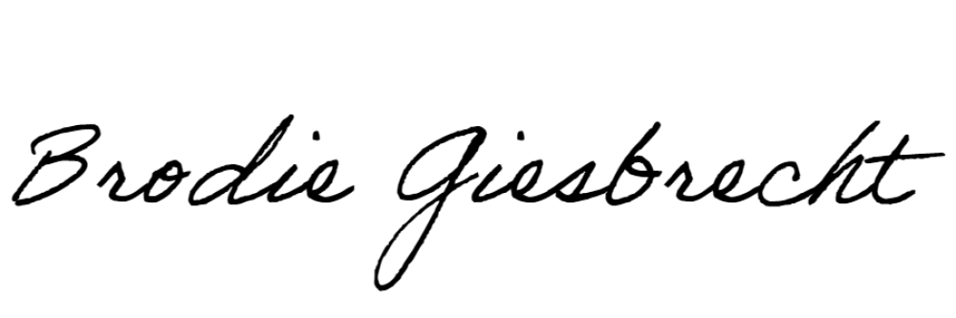
Yours in health and fitness,

Starting pictures
Please attach your starting pictures in the space provided below.

